**Smart Irrigation System using Robot:**

**Components Required:**

1. AURDINO UNO
2. L293D SHIELD
3. SERVO MOTOR SG90
4. DC PUMP
5. ULTRASONIC SENSOR
6. MOISTURE SENSOR
7. CHARGING MODULE (TP4056)
8. JUMPER WIRES
9. LI- ON BATTERY
10. BATTERY HOLDER
11. 100RPM GEARED MOTORS
12. MOUNTING
13. WHEELS
14. SCREWS
15. PLASTIC ROD
16. WATER CINTAINER

**Details Of Components:**

**AURDINO UNO**

An Aurdino uno is a microcontroller board that is used to control the various functions of a plant watering robot. The Aurdino uno is programmable and can be used to create and execute the different functions required by the robot, such as moving the robot, turning on the water, and controlling the ultrasonic sensors. Arduino UNO is a low-cost, flexible, and easy-to-use programmable open-source microcontroller board that can be integrated into a variety of electronic projects. This board can be interfaced with other Arduino boards, Arduino shields, Raspberry Pi boards and can control relays, LEDs, servos, and motors as an output.

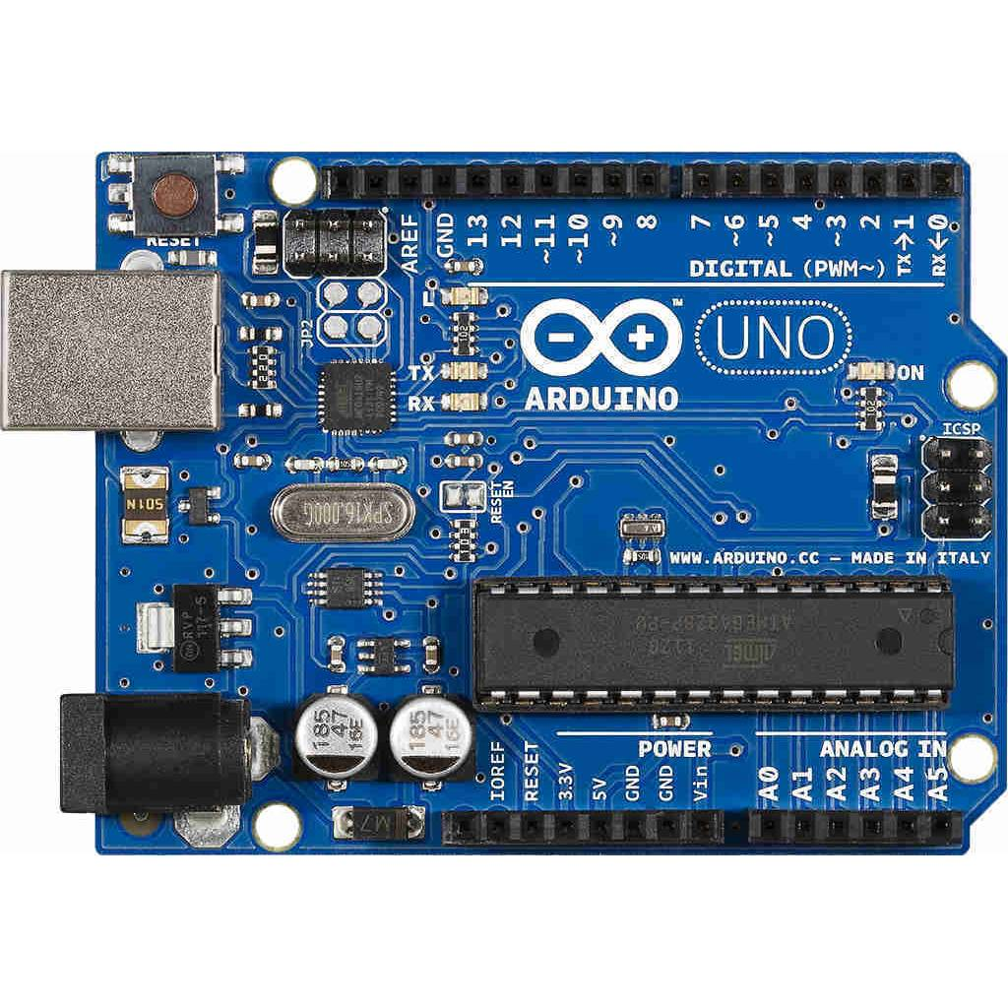

**L293D SHIELD**

The servo motor is used to control the angular position of the pipe, which ensures equal distribution of water to the soil. L293D shield is a driver board based on L293 IC, which can drive 4 DC motors and 2 stepper or Servo motors at the same time. Each channel of this module has the maximum current of 1.2A and doesn't work if the voltage is more than 25v or less than 4.5v.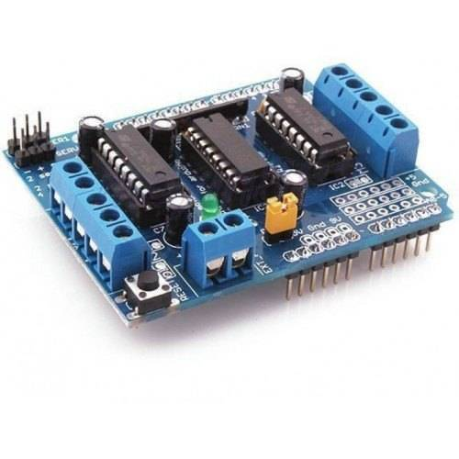

**SERVO MOTOR SG90**

SG90 is a popular micro servo motor commonly used in hobbyist and DIY projects. It is a small, low-cost servo motor that can rotate 180 degrees with a maximum torque of 1.8 kg-cm. It operates at 4.8-6V and has a weight of approximately 9 grams, making it ideal for small-scale robotics and model control applications. Tiny and lightweight with high output power. Servo can rotate approximately 180 degrees (90 in each direction), and works just like the standard kinds but smaller. You can use any servo code, hardware or library to control these servos. Good for beginners who want to make stuff move without building a motor controller with feedback & gear box, especially since it will fit in small places. It comes with a 3 horns (arms) and hardware.

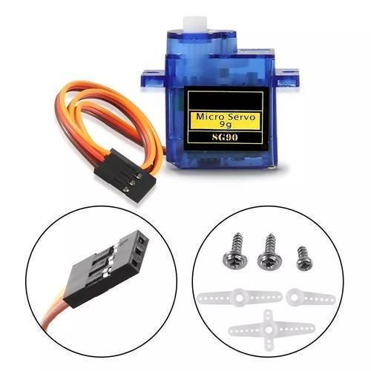

**Ultrasonic Sensor**

It uses the ultrasonic sensor to measure the level of water in the reservoir and sends this to the microcontroller. Based on this the microcontroller decides which of the pumps to be deployed for irrigation at a particular time.

Ultrasonic sensors are used to detect the presence of a plant and measure the distance between the plant and the robot. These sensors can help the robot identify which plants need watering and measure the amount of water required. They are commonly used in plant watering robots to ensure that the robot waters only the plants that need it, without wasting water on plants that have sufficient moisture.

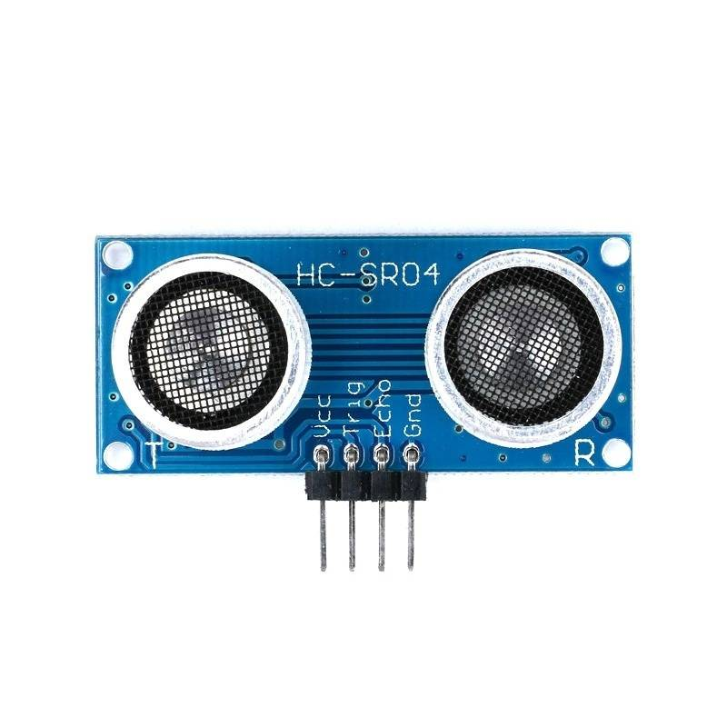

**DC PUMP**

A DC pump controlled by an Arduino microcontroller is a type of system that uses an Arduino to control the operation of a DC pump. The Arduino can be used to turn the pump on and off, as well as to control the flow rate and direction of the water.This component is used to extract water from a container or a source and pump it to the plant. It is usually powered by electricity and has a flow rate that can be adjusted to control the amount of water dispensed to the plants.

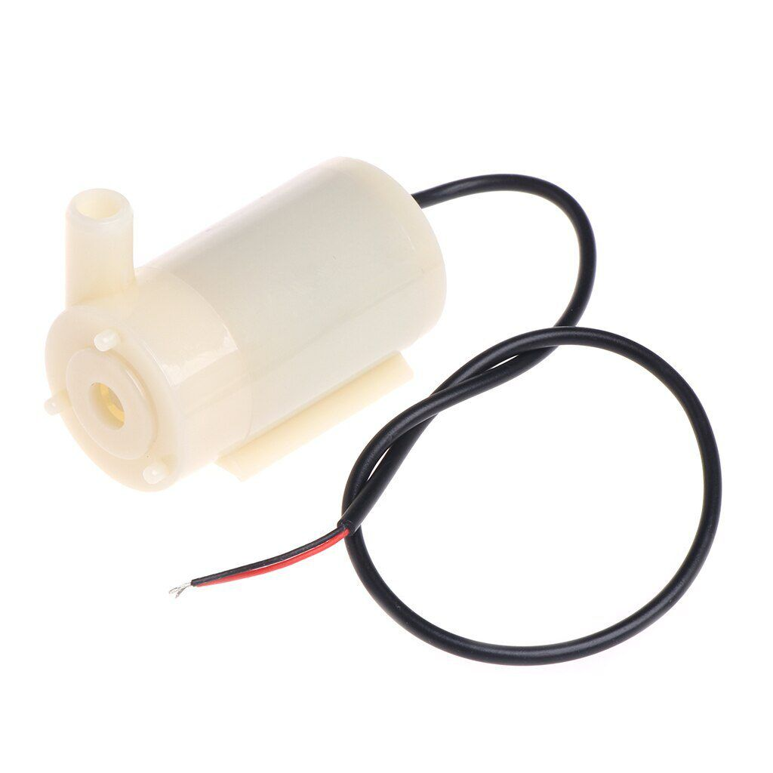

**MOSITURE SENSOR**

This component senses the moisture level of the soil and sends a signal to the plant watering robot to dispense water if the moisture level is low. It is an essential component for the robot as it ensures that the plants receive the right amount of water without being over- or under-watered. The soil moisture sensor sense the soil moisture level, calculates how much water should be given and saves that value Soil moisture sensor is a novel device which senses the moisture content in the soil, and with suitable mechanism allows water to be irrigated depending on the moisture content of the soil.

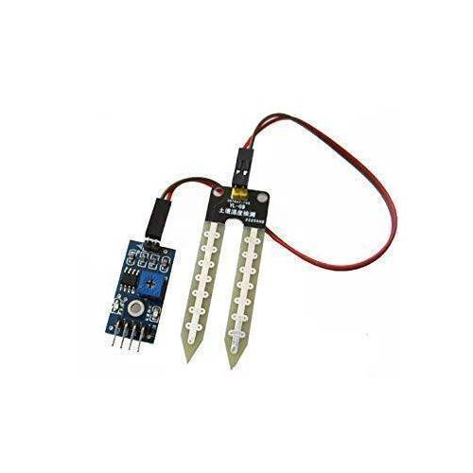

**CHARGING MODULES TP4506**

TP4056 Battery Charging Module is one of the most used module for charging single cell Li-ion Batteries. It provides for different connections for battery and output. This module is made for charging rechargeable lithium batteries using the constant-current/constant-voltage (CC/CV) charging method. In addition to safely charging a lithium battery the module also provides necessary protection required by lithium batteries.

Charging modules are used to recharge the batteries used in the plant watering robot. These modules are typically connected to the power source and the batteries. They allow the batteries to be charged without overcharging, which can damage the batteries.

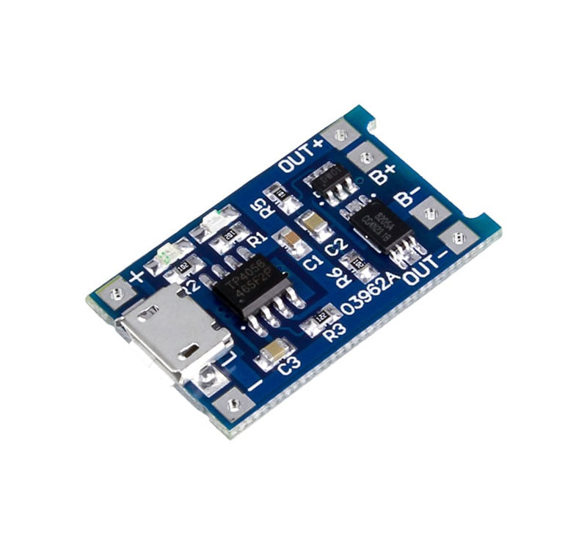

**RELAY**

The relay will control the flow of water from the pump based on actions given to Genuino 101. The water pump will be inside the water pump connected with a pipe. When the pump is turned on it will supply water from the pot through the connected pipe.

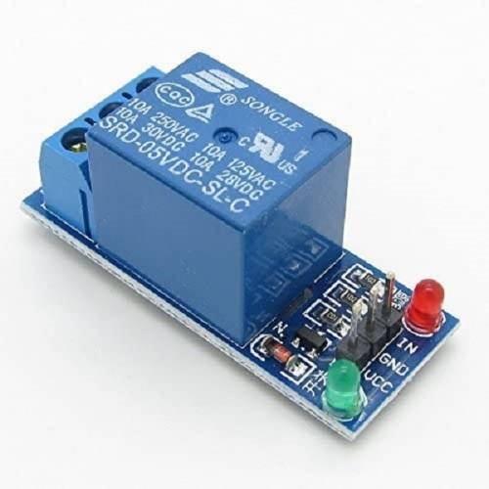

**BATTERY HOLDERS**

Battery holders are used to hold the batteries that power the robot. These holders are designed to securely hold the batteries, preventing them from slipping out during operation. Often, these battery holders are designed to fit standard rechargeable batteries.

The primary function of a battery holder is to keep cells fixed in place safely and securely while conveying power from the batteries to the device in question.

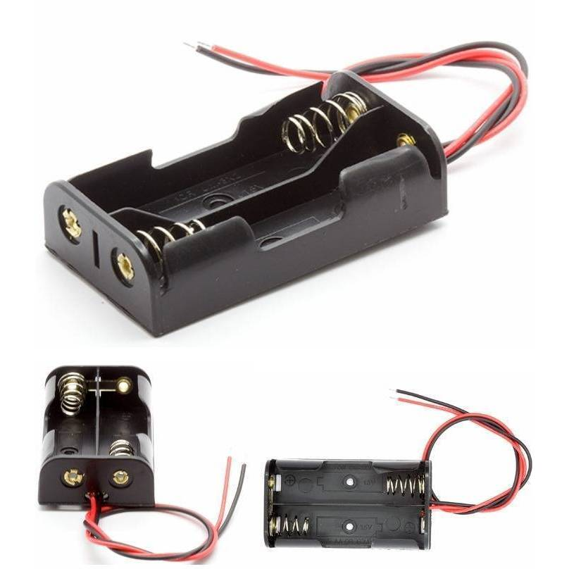

**100RPM GEARED MOTORS**

A 100mp geared motor is a motor with a high torque output, which is necessary for a plant watering robot to be able to move and operate properly. The motor is typically connected to gears to increase the torque while lowering the speed. Electric Gear motors are used in applications that require high output torque and lower output shaft rotational speed, especially where space and available power are limited.

100 RPM can be used in all-terrain robots and a variety of robotic applications. These motors have a 3 mm threaded drill hole in the middle of the shaft thus making it simple to connect it to the wheels or any other mechanical assembly.

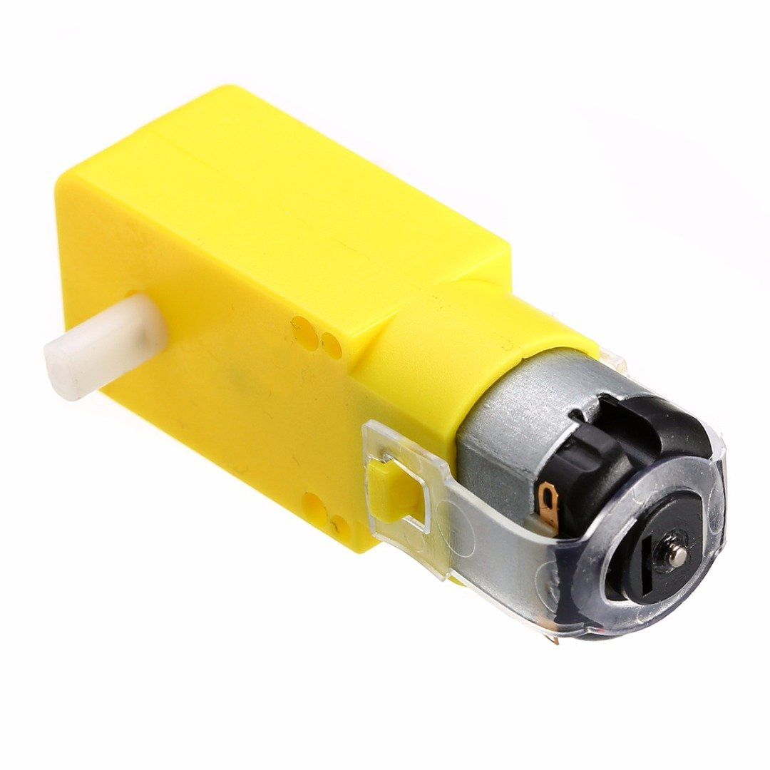

**JUMPER WIRES**

Jumper wires are used for making connections between items on your breadboard and your Arduino's header pins. Use them to wire up all your circuits.

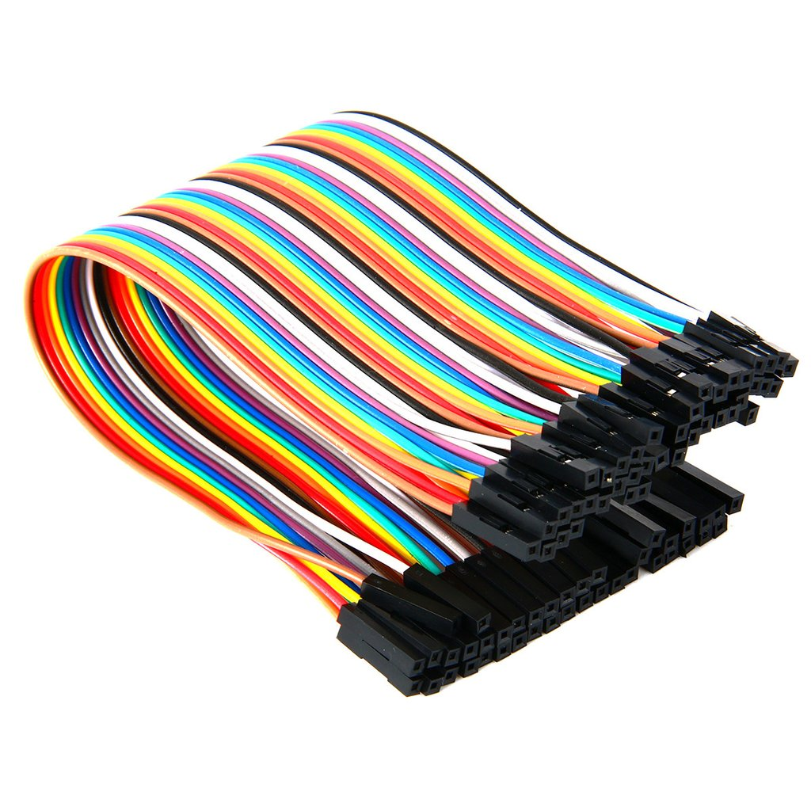

**Li-On BATTERY**

A lithium-ion or Li-ion battery is a type of rechargeable battery which uses the reversible reduction of lithium ions to store energy.

